**Feasibility Analysis**

**Summary of our Survey:**

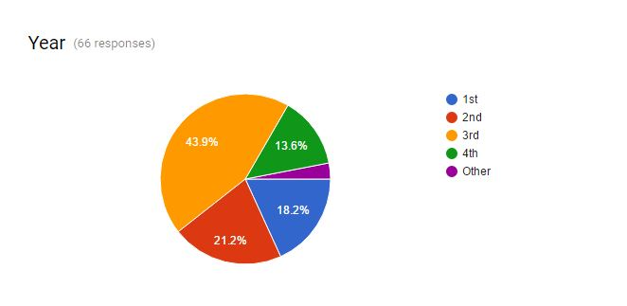

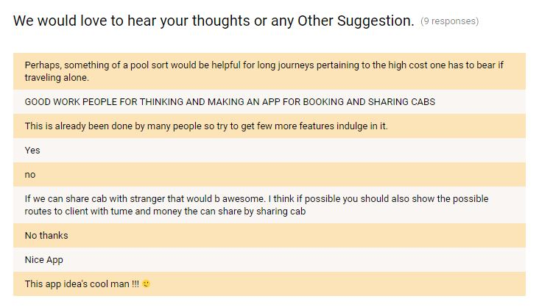

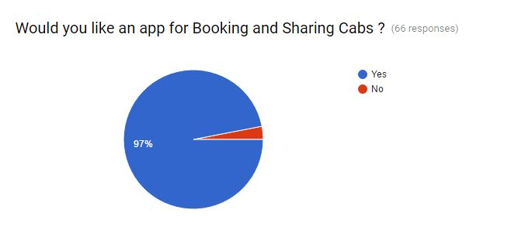

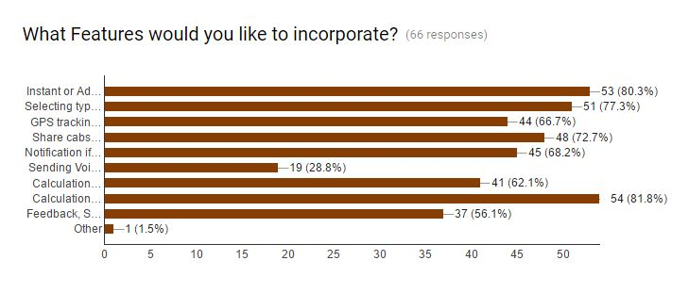**What if the system wasn’t implemented?**

If the app wasn’t implemented then the user will have to rely on traditional methods of calling cabs which is phone call. Without the use of GPS tracking they won’t be able to know the location of the cab, they won’t know about the answer to some simple questions like whether the cab started from its destination or not, or if it has started where it has reached?, how much time will it take to reach the user? . Also the process of sharing the cab would be difficult without this app.

**What are current process problems?**

With current process user can’t book cabs in advance. They need driver’s number to communicate with them. Even after calling the cab long time ago it doesn’t reach the user within the time given. Users sometimes are not aware of the fare for different location they have to rely on driver’s word for it.

**How will the proposed system help?**

* Our system will help users to share cabs with other students by sending notification to every other user.
* It will also help user to book the cab in advance.
* GPS tracking feature will help them in getting the exact location of cab they have booked so that they can plan their activity accordingly.
* The voice message system provides better medium of communication between user and driver/guard.
* NIIT University can get the distance travelled by faculties which will help them in making payment to vendor.

**What will be the integration problems?**

A feature implemented in our system is GPS tracking which makes use of the various maps technologies currently being used like HERE Maps, Google Maps and other 3rd party maps etc.

Firstly, If we want to integrate the functionality of any miscellaneous maps onto our app, It’ll be difficult to find APIs of other 3rd party apps so as the developers of those apps don’t make it public, although Google and Microsoft provide the APIs for their respective maps and are most commonly used.

Secondly during integration process of any maps API we can encounter bugs such as search not working, selecting a location from the search bar doesn’t pin it on the map, photos search API not working resulting in showing places/destinations without any images and many other unknown bugs.

Another issue that can be encountered is when the map displays but no map tiles are loaded on the app. This occurs mainly when the app hasn’t been granted INTERNET permission. For this we will integrate android.permission.INTERNET permission and the com.google.android.maps library into our code for the app to function properly.

**Is new technology needed? What skills?**

As the world of technology is progressing further year by year, we are seeing innovation in terms of new products. For Example – smartwatches (particularly known as Android Wear) which is going to be a very useful product for the future. Now apart from the android API’S the Watch API‘S are also available, which means integration of our app will be more useful and beneficial since users will be able to use the application from their wrists without even taking out their smartphones. Innovation won’t stop neither will be innovation in terms of technology. Every year a tech/product will be available which has some new functionality/features. This is necessary and good as the app will then be able to be used in more ways and developers will find some innovative ideas for the app to work in a more creative fashion in the future which can’t be thought of in the present.

If on viewing from a consumer’s (End User) perspective no skill is required to use the app. Once the user uses the app for the first time he/she will become familiar with the working of the app/what it does which is quite simple.

In terms of use, developers new Android OS’s will come consequently new API’s, new features will also come so we will have to keep up with the new releases in the coming future. We’ll constantly have to learn about the new features and how to implement them in a creative way so as to become a successful developer.

**Facilities that must be supported by the proposed system?**

It enables user to book\share cabs and track the location of the cab.

Cab Sharing- This feature searches for two or more users who are going to the same destination. It sends a pop-up notification asking a particular user whether they want to share the cab or not. Upon sharing a cab the total fare of the cabs will be less as compared to individuals. This is not applicable in pre-defined destinations though.

SMS Automation – This feature lets the driver, know that his cab is booked, plus it is also send to the guard to make him aware that this particular driver’s cab has been booked.

GPS Tracking – Through this feature the user keeps track of where the cab is, soon after placing the booking.